

Design Document

Final version



Bilger yahov

oLEKSANDR SUPRUNENKO

ILIA NIKUSHEV

GEORGI CHISHIRKOV

LYUBOMIR DIMOV

MENGCHUAN LIU

Traffic Lights System

Table of Contents

Introduction 3

Class Diagram 4

Renderable inheritance overview 4

Component classes 4

Crossing classes 5

Simulation classes 6

Crossing container (Recycle bin and saved crossings) 7

7

Undo classes 7

7

Traffic manager Grid and System state classes 8

Description of the classes and their members 9

Sequence Diagrams 10

Select a crossing to place 10

Place a crossing 10

Remove a crossing 11

Create a simulation 12

Save a simulation 13

Load a simulation 14

Edit a road traffic flow 15

Start a simulation 15

Stop a simulation 16

Pause a simulation 16

Restart a simulation 17

Undo an action 17

Redo an action 18

Save simulation results 19

Show the help window 19

Exit application 20

Override simulation 21

Show simulation result 21

Select crossing’s component to make changes 22

Set current active crossing 22

Start simulating pedestrians 23

Access “Saved” crossing 24

Access “Removed” crossings 25

Empty the recycle bin 25

Graphical User Interface 26

# Introduction

This document gives information about the class diagram for the *“Traffic Lights”* application. Description of the classes and the attributes and methods in each class is given. Furthermore, some sequence diagrams of the application are presented.

The class diagram is a static diagram. It represents the static view of the application. Our class diagram is not only used for visualizing, describing and documenting different aspects of a system but also for constructing executable code of the software application. The class diagram describes the attributes and operations of a class and also the constraints imposed on the system.

Our class diagram can be mapped directly with object oriented languages. It shows a collection of classes, interfaces, associations, collaborations and constraints.

The UML diagrams like activity diagram, sequence diagram can only give the sequence flow of the application but class diagram is a bit different. So it is the most popular UML diagram in the coder community.

In the document can be found sequence diagrams which purpose is:

* Draw the activity flow of a system.
* Describe the sequence from one activity to another.
* Describe the parallel, branched and concurrent flow of the system.

# Class Diagram

Note: All properties, fields, methods are Public unless otherwise specified

## C:\Users\user\Desktop\ProCP\Renderable.JPGRenderable inheritance overview

## Component classes

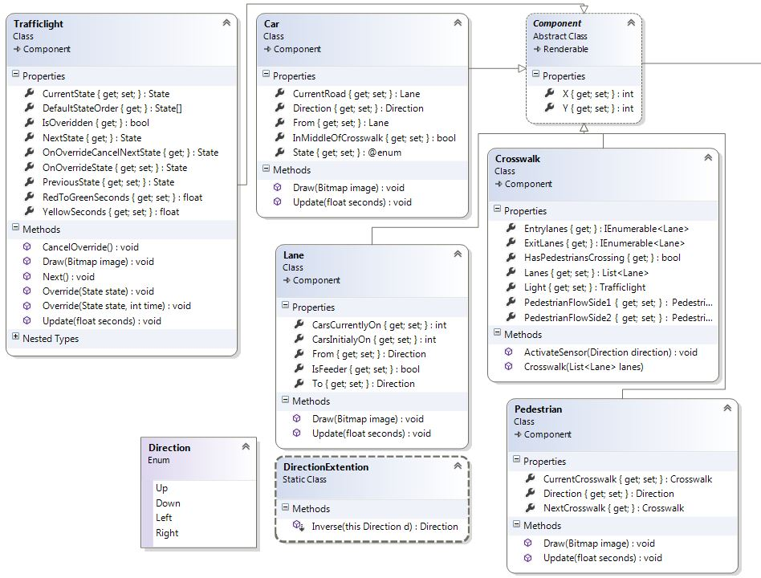

## Crossing classes

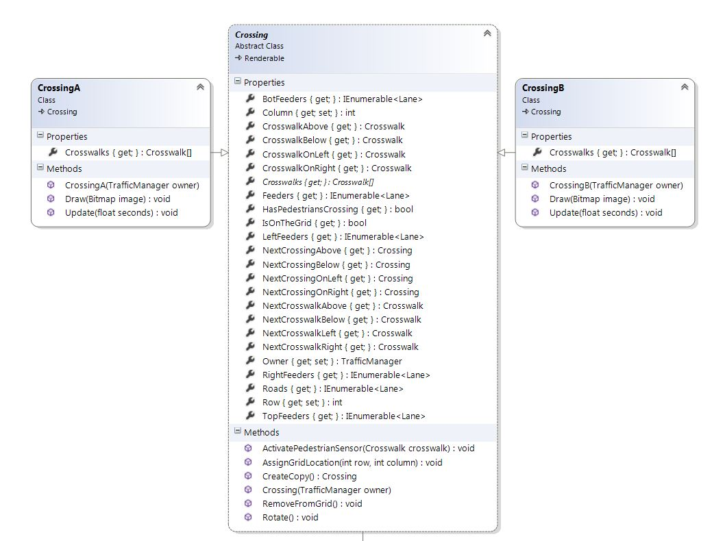

## Simulation classes

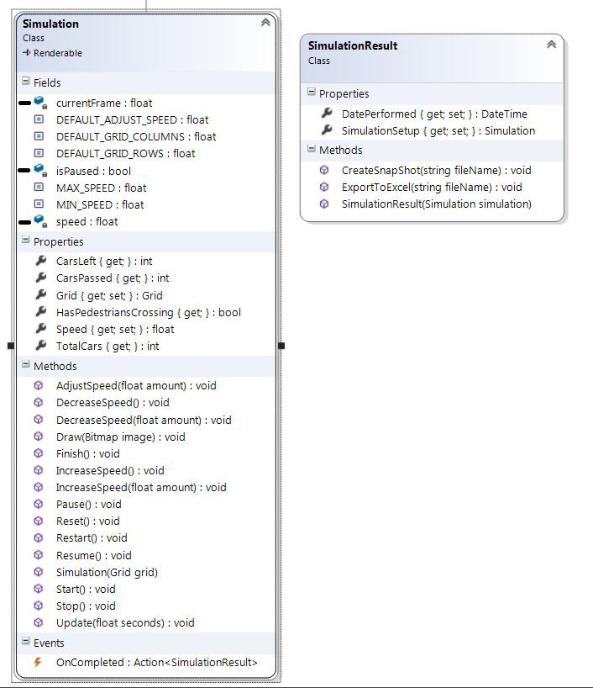

## Crossing container (Recycle bin and saved crossings)

## 

## Undo classes

## 

## Traffic manager Grid and System state classes

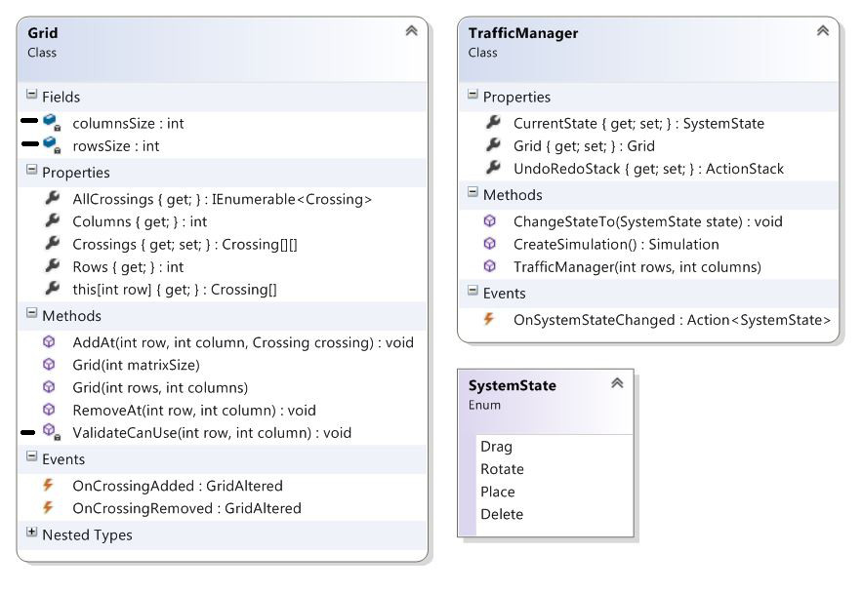

# Description of the classes and their members

The description for the classes and members can be viewed in the separate folder Class documentation.

# Sequence Diagrams

## Select a crossing to place

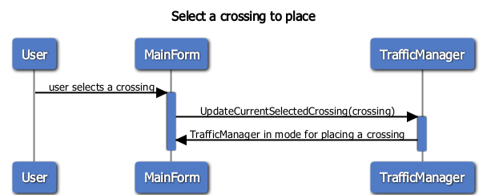

## Place a crossing

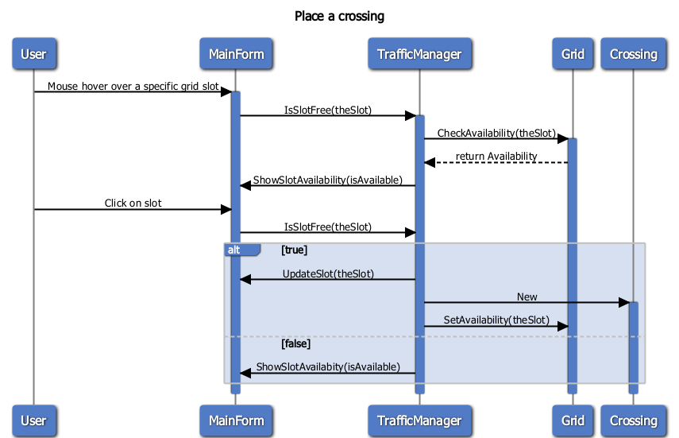

## Remove a crossing

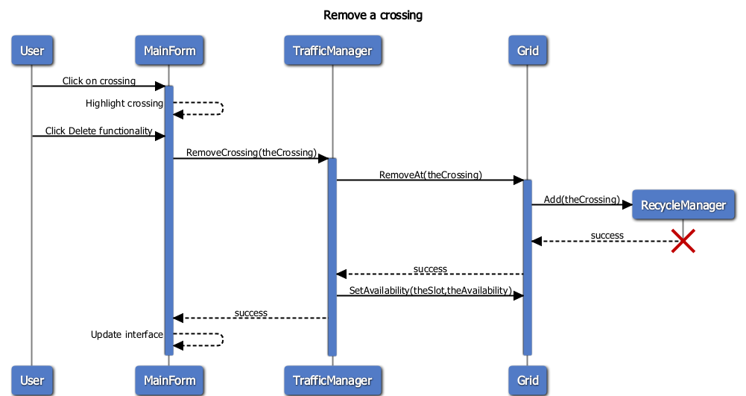

## Create a simulation

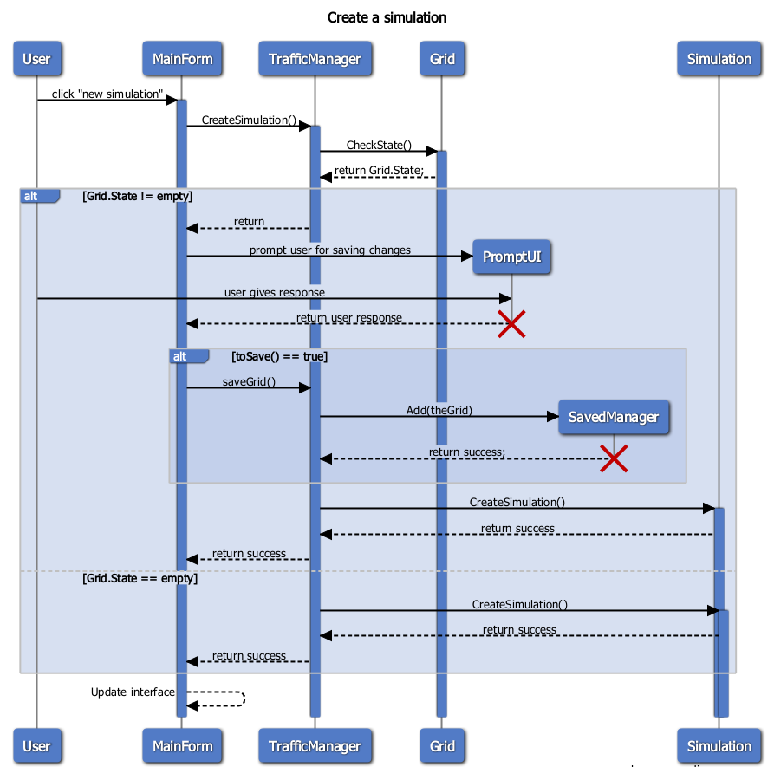

## Save a simulation

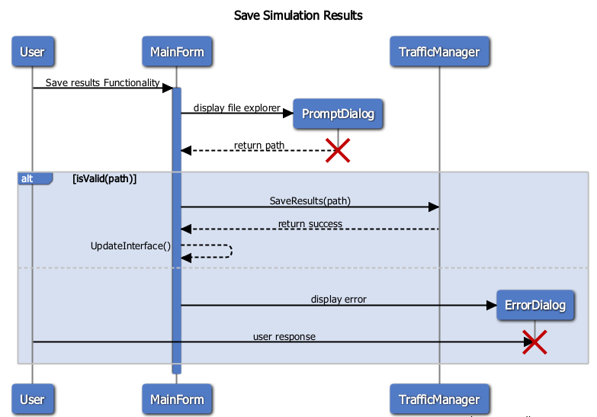

## Load a simulation

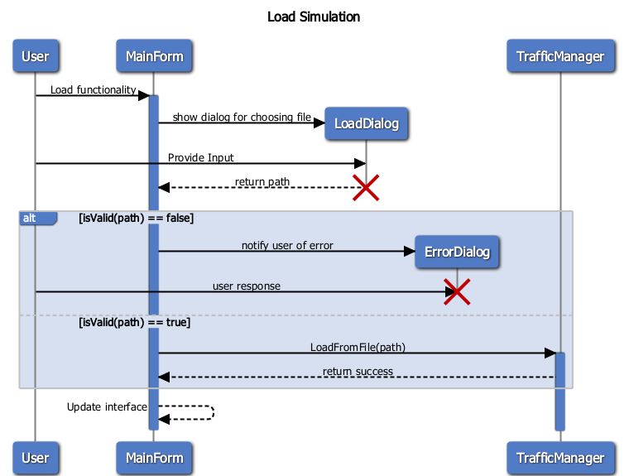

## Edit a road traffic flow

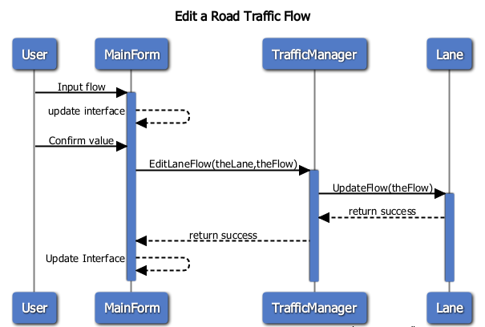

## Start a simulation

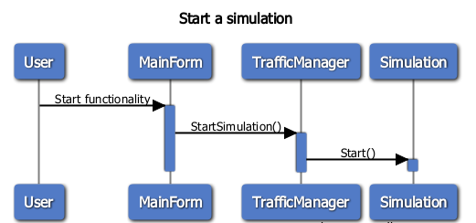

## Stop a simulation

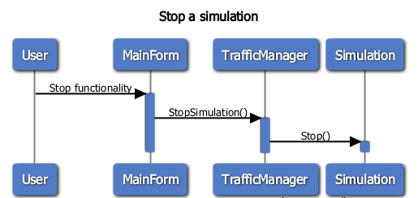

## Pause a simulation

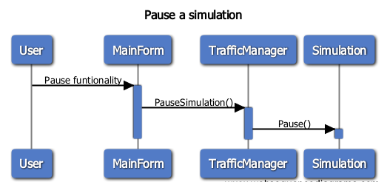

## Restart a simulation

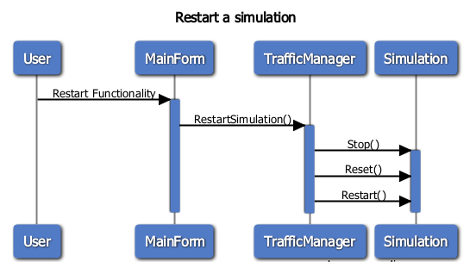

## Undo an action

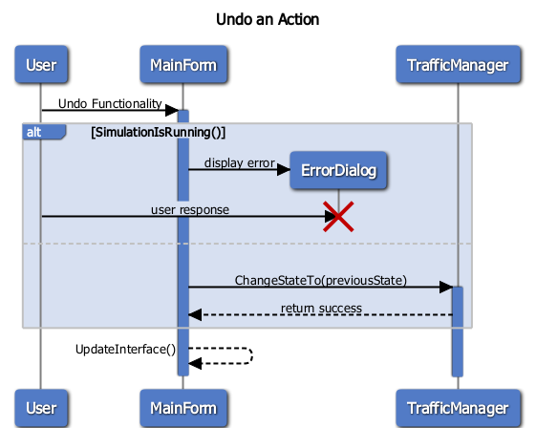

## Redo an action

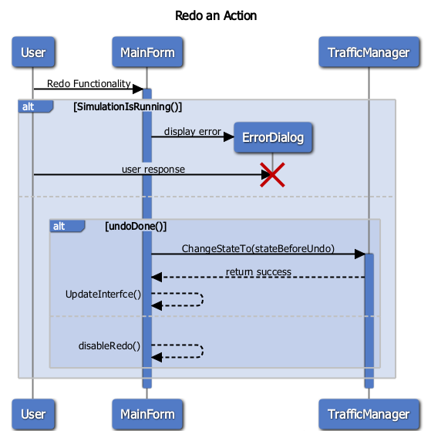

## Save simulation results



## Show the help window

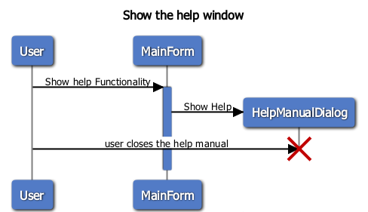

## Exit application

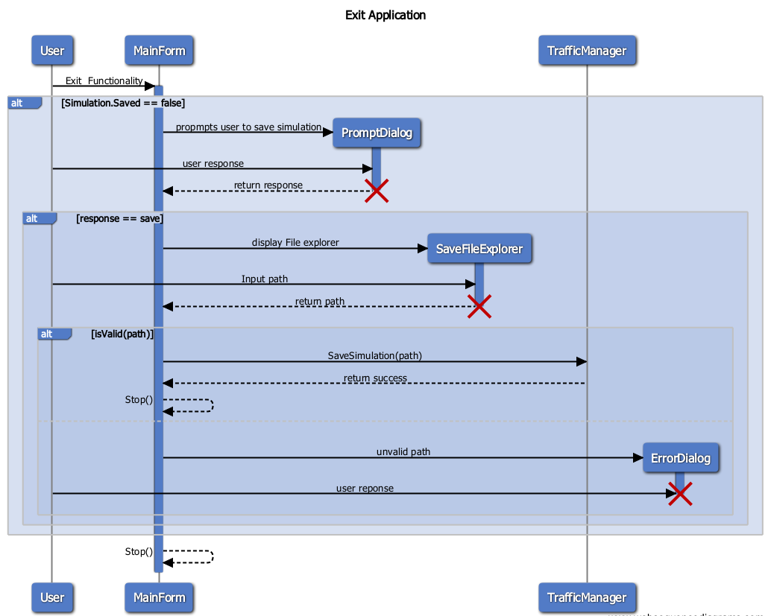

## Override simulation

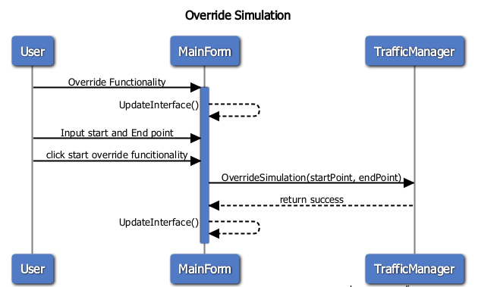

## Show simulation result

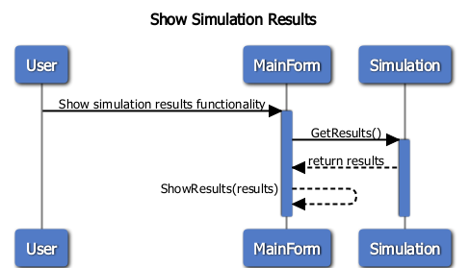

## Select crossing’s component to make changes

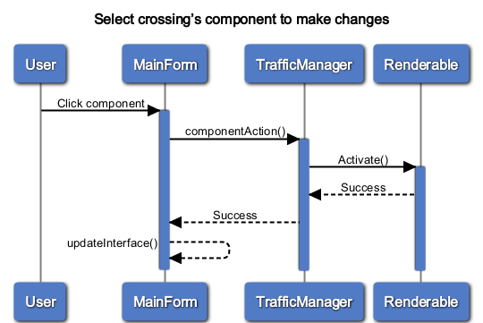

## Set current active crossing

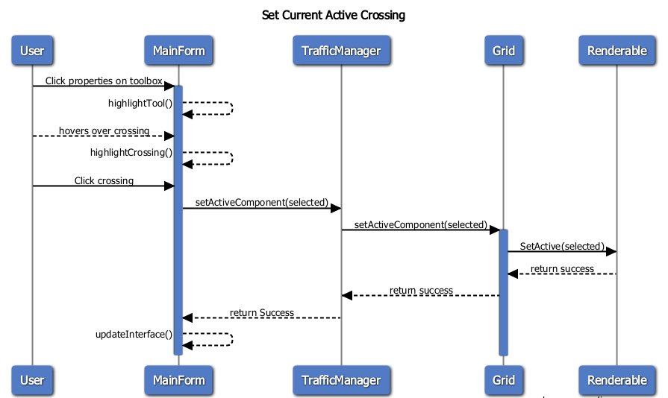

## Start simulating pedestrians

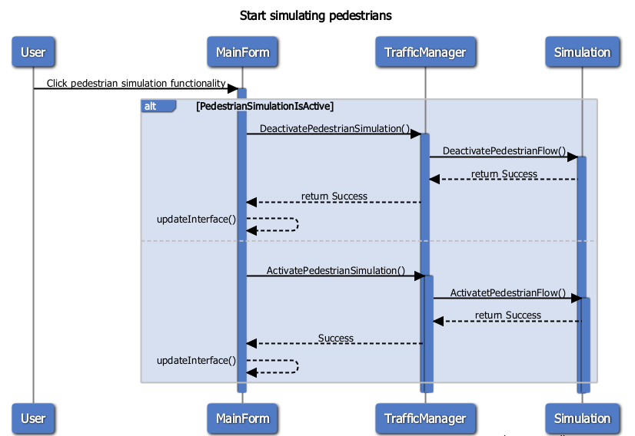

## Access “Saved” crossing

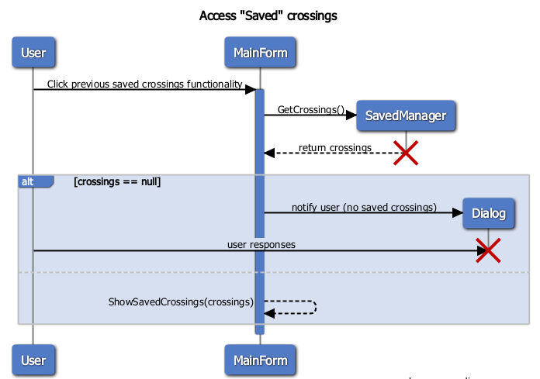

## Access “Removed” crossings

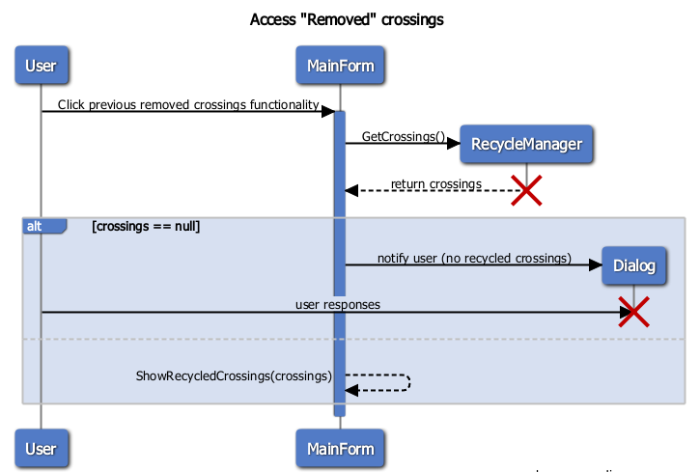

## Empty the recycle bin

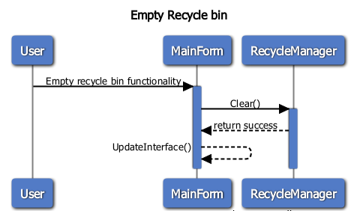

# Graphical User Interface

